Finding your on course resources

- To find your online course resources, expand the ‘Online Courses’ menu by clicking the ‘Plus’ button:

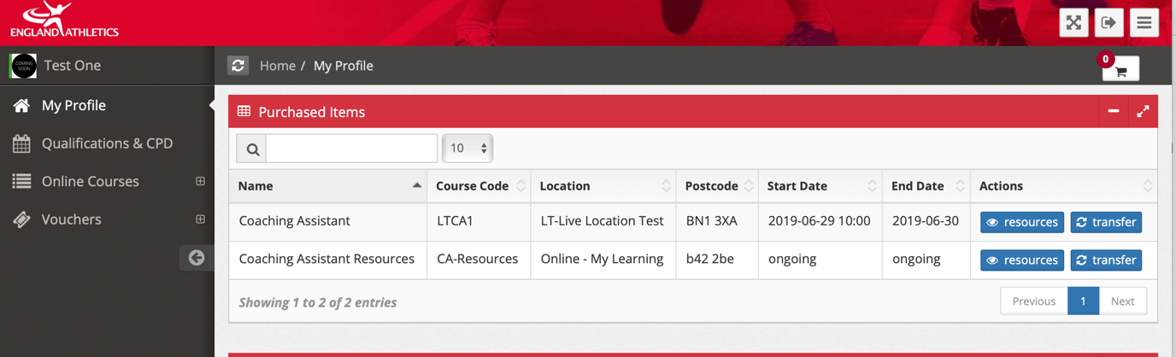

- Click on ‘My Courses’:

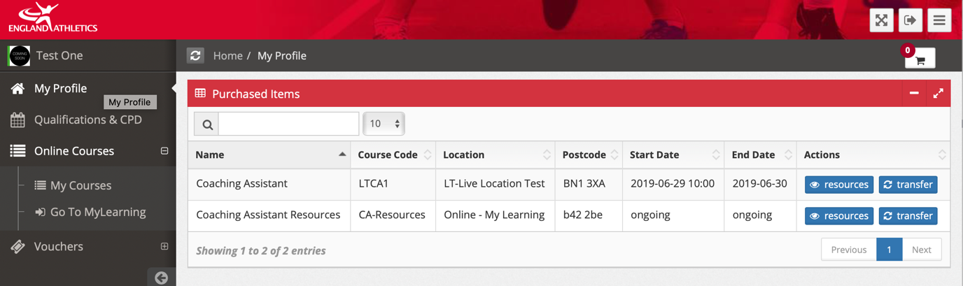

- Click on the ‘Go to course’ hyperlink

